

**IMPROVED AGILE FRAMEWORK-SCRUM**

**Thesis**

**Submitted By**

|  |  |  |  |  |  |
| --- | --- | --- | --- | --- | --- |
|  | **Name** | |  | **ID** | |
|  |  |  |  |  |  |
| Samima Sultana | | | 16-32012-2 | | |
|  | | |  | | |
| Jasaus Salehin Prapty | | | 16-32014-2 | | |
|  | | |  | | |
| Abdullah Al Mamun | | | 16-32966-3 | | |
|  | | |  | | |
| Akram Hossain | | | 17-35325-2 | | |
|  |  |  |  |  |  |

Department of Computer Science

Faculty of Science & Technology

**AMERICAN INTERNATIONAL UNIVERSITY-BANGLADESH**

7th May, 2022

**Declaration**

We declare that this thesis is our original work and has not been submitted in any form for another degree or diploma at any university or other institute of tertiary education. Information derived from the published and unpublished work of others has been acknowledged in the text and a list of references is given.



**Jasaus Salehin Prapty**

**16-32014-2**

**CSE**



**Samima Sultana**

**16-32012-2**

**CSSE**



**Akram Hossain**

**17-35325-2**

**CSE**

**Abdullah Al Mamun**

**16-32966-3**

**CSE**

**Approval**

The thesis titled **“Improved Agile Framework-Scrum”** has been submitted to the following respected members of the board of examiners of the department of computer science in partial fulfillment of the requirements for the degree of Bachelor of Science in Computer Science on 7th May, 2022 and has been accepted as satisfactory.

**MD.AL-AMIN**

Lecturer & External

Department of Computer Science

American International University-Bangladesh

**ABHIJIT BHOWMIK**

Associate Professor& Supervisor

Department of Computer Science

American International University-Bangladesh

**DR. Tafazzal Hossain**

Professor & Dean

Department of Computer Science

American International University-Bangladesh

**DR. Md. Abdullah Al-Jubair**

Assistant Professor & Head

Department of Computer Science

American International University-Bangladesh

**Dr. Carmen Z. Lamagna**

Vice Chancellor

American International University-Bangladesh

**Acknowledgement**

First of all, we would thank almighty for his grace in completing our thesis successfully on time. We would like to express our cordial thanks to the Faculty of Science & Information Technology to keep thesis/project credit in the curriculum of the graduation program and give us a scope of gathering knowledge.

We are also thankful to our Thesis Supervisor **ABHIJIT BHOWMIK**, from the core of our heart for his kind support, guidance, constructive, supervision, instructions, advice and for motivating us to complete this thesis.

Furthermore, we would like to show our grateful feeling to all of our teachers, who once taught us and was our course coordinator. They are always patient to help us out with any regarding our thesis.

**Abstract**

Scrum is widely used in many companies in our country. Here we tried to find out the best of Scrum, its advantages, its disadvantages. We also tried to find out the problems of implementing Scrum. For this purpose, to succeed we have conducted a survey on Scrum. After performing the survey, we gained a lot of knowledge about scrum in the current market. We find out most common problems in it. As well as we have proposed some suitable solutions for overcoming the problem as well. We hope the survey responses as well as the proposed solutions will help the companies to overcome the existing problems and improve the productivity.

**Table of Content**

**Chapter 1: Introduction**

1.1 What is Agile framework................................................................................8

1.2 Examples of Agile framework ………………………………………..……..8

1.3 What is Scrum…………………………………………………………….…10

1.3.1 Introduction…………………………………………………………10

1.4 Aims and Objectives........................................................................................12

**Chapter 2: Literature Review**

2.1 Introduction.....................................................................................................14

2.2 Core Background Study..................................................................................15

2.3 Review Based on Methods..............................................................................16

2.4 Review Based on results..................................................................................16

2.5 Conclusion.......................................................................................................17

**Chapter 3: Research Methodology**

3.1 Introduction.....................................................................................................18

3.2 Problem finding...............................................................................................18

3.3 Proposed solution.............................................................................................21

3.4 Proposed Model………………………………………………………………22

3.5 Summary of proposed model …………………………………………………22

**Chapter 4: Result and Analysis**

4.1 Survey Results………………………………………………………...…..…..24

4.2Result analysis ...................................................................................................34

4.3Advantages of Proposed Model..........................................................................34

**Chapter 5: Future Work**

5.1 Future Work.......................................................................................................35

**Chapter 6: Conclusion**

6. Conclusion...........................................................................................................36

**Chapter 7: References**

7.References…………………………………………………………………..……37

**List of Figures**

Fig 1.3.1: Scrum Framework…………………………………………………….10

Fig 3.2.1: Information about employees training………………………………...19

Fig 3.2.2: Information about the size of a team ………………………………….19

Fig 3.2.3: Information about sitting position……………………………………..20

Fig 3.2.4: Information about quality assurance…………………………………...20

Fig 3.2.5: Information about schedule controlling…………………………………21

Fig 3.4.1: Proposed model of scrum framework……………………………………22

Fig 4.1.1: Information about age………………………………………………….....24

Fig 4.1.2: Information about employees role………………………………………..25

Fig 4.1.3: Information about organization size……………………………………...26

Fig 4.1.4: Information about organizations work……………………………………28

Fig 4.1.5: Information about office environment……………………………………29

Fig 4.1.6: Information about product owners knowledge……………………………31

Fig 4.1.7: Information about management cooperation’s……………………………32

Fig 4.1.8: Information about home office……………………………………………32

Fig 4.1.9: Information about team responsiveness……………………………………33

**Chapter One: Introduction**

**1. Introduction:**

**1.1 What is Agile framework?**

**1.1.1 Definition:** Agile is a process or pathway where frequent changes happen. Those frequent changes can help agile team to deliver any product to the customers in quicker time with lesser problems. In agile the work is delivered by the team in small boxes instead of doing everything in a single move. This helps the team respond for any problem and change that easily. We cannot say that agile uses many techniques to improve the outcomes quality within the shortest amount of time. There are many ways to work with agile. Some are being changed or modified as well. If we put everything together, we still can say them agile framework.

**1.2** **Examples of Agile framework:**

**Scrum**– Scrum is one of the most popular frameworks. It is believed that scrum doubles the outcome that means it can produce twice outcome in half the time. It is also very old framework. In Scrum sprint is very important term. After each sprint a set of tasks is delivered. Scrum is built to deliver complex and big problem to be solved within minimum amount of time. The outcome of scrum is needed to be satisfactory as well. In scrum the team follows sprint. A sprint usually last between two and four weeks.

**XP**

The full form of XP is Extreme Programming. This framework is also focused on team. That means teamwork is very important here. It also runs on sprint. In xp small releases happen with short sprints. This happens for a purpose which is, any changes can be applied easily in short sprints. XP follows values like,

* plainness
* Passage
* Clockwork feedback

In xp the development team tries to understand what customer wants then offer them a suitable work and proceed within understanding. This makes XP better.

**Dynamic Systems Development Method (DSDM)** - Dynamic systems development method is very popular framework. It is also reliable. It is the improved or modified version of Rapid Application Development. It not only focuses on the development team but also focuses on the whole process of the project. It monitors every aspect of the process as well as the organization. From the very initial stage of a project to the finishing touch DSDM is there. That’s why it’s usage is increasing day by day.

**Feature Driven Development (FDD)** - Feature-driven development is also a very popular framework. We can say that FDD is a mixed framework. Benefits can be get from both agile methodologies as well as model driven development by using FDD. FDD can be used for both small organizations to bigger organizations. Nowadays FDD is also used in various companies to get its full benefit.

**Adaptive Software Development (ASD)** – Adaptive software development is also an agile framework. We can say that RAD is followed by ASD. That means ASD has RAD’s feature as well. ASD believes end user is most important aspect here. Things are being done here for the betterment of end users. It allows the end user and development team communication which helps to improve the quality of the product.

**Disciplined Agile (DA)** – Disciplined Agile is also an agile framework. Here, in DA it also has main focus on its end users. The basic idea here is if the end user is happy then the project is successful. Mainly DA is used in big companies. These companies who have huge staff can use DA for getting better outcome.

**1.3** **What is Scrum?**

**1.3.1 Introduction:**

Scrum is one of the popular frameworks in the current time. Scrum became very popular because it can utilize very well. It has the ability to multiply the output. That means it can deliver twice the output from single output. Which is the best possible thing of scrum. Scrum is also very lightweight that means it is very easy to use and implement. The success rate of using scrum is very high in the current market.

**The Scrum Framework**

Scrum framework is designed to complete the complex tasks easily and efficiently with a minimum time limit. This framework is very popular for its productivity as it can deliver twice the output. Sprint is the key feature in scrum which is also a time limited event to get better productivity. Each sprint lasts two to four weeks. After that another sprint occurs with new sprint backlog. When there remain no more requirements that means the sprints are new completed and final product is ready. This is a very simple process to understand. That’s why any company can master scrum within no time a gets its advantage.

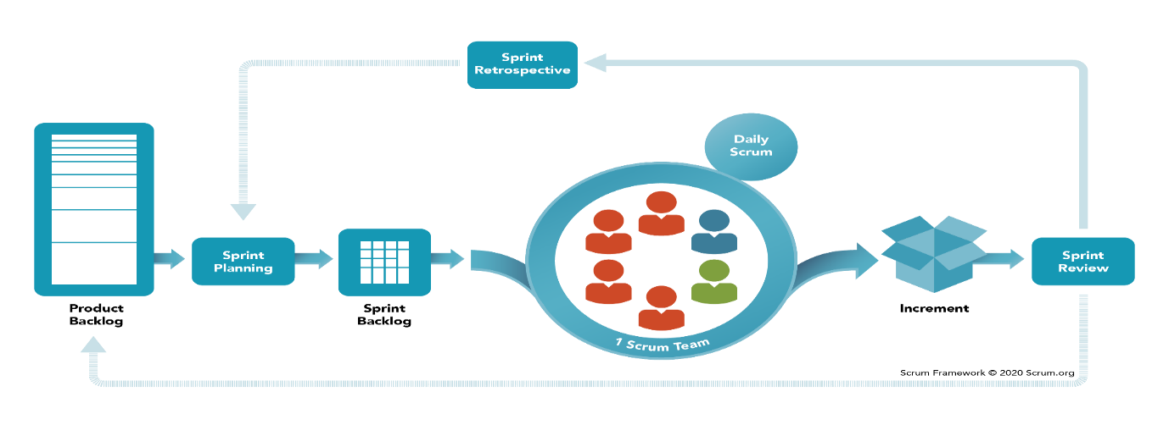

**Fig 1.3.1: Scrum Framework**

**Scrum Events**

There are many events occur in scrum to get the things done. Some of them are predefined and some take place according to the circumstances. Every event has its own value and by performing every event successfully the final outcome is up to the mark.

Here are some events that occurs during the process -

**Product backlog:** It is one of the initial steps. After starting any project, the first thing to do is planning. After planning everything goes on to product backlog list. A set of tasks is stored here. Product backlog list updates regularly that what the beauty and benefit of using scrum. Changes can be done anytime.

**Sprint backlog:** The set of tasks stored in product backlog are forwarded here. Sprint backlog list provides all necessary tasks and ideas for a sprint to occurs. When there is no requirement left the sprint backlog is done.

**Sprint:** Sprint is the key feature of scrum framework. It can be called as iteration as well. Development team work here to get the things done. Each sprint can last from two to four weeks. After each sprint new product increment arises, which helps to get better result. Product vision is also arisen here in this time. By product vision we can measure the work quality and needing’s.

**Integration:** Integration is the final step. When, there is no more requirements or product increment, integration happens. Here after finishing everything documentation and final release happens. After that we can say that the product is ready to deliver.

Although scrum is very popular and effective framework, some roles play a vital role to get the best outcome to organize everything properly. They are-

**Product Owner**

Product owner play a vital role for the overall project. All the requirement for product backlog list comes from product owner. If the product owner knows clearly that what he wants from the team then the work becomes easy. The more the product owner can describe everything to the team the better the chances of getting better outcome.

**Scrum Master**

Scrum master also plays a vital role in the overall process. Scrum master binds product owner and the development team together. The more they communicate the better the outcome can be scrum master manage everyone including his team. He monitors, mentors everyone. He also provide suggestions as well.

**Development Team**

After getting all the requirements from product owner and being guided by the scrum master its everything up to the development team. They have to think, implement and get the product ready within a certain amount of time. We can say they are the warriors. Because they work really hard to make possible someone’s imagination into reality.

**Why do we need scrum?**

Scrum is very popular for being very easy to handle. Unless other complex frameworks scrum is very easy. Simple training can be effective enough to understand the process. As it’s very handy and easy, using scrum can increase the productivity significantly. That’s why we need scrum.

**1.4 Aims and objectives:**

**Core objectives:**

We have conducted survey on different employees from different companies. We have asked them about scrum. Its advantages and disadvantages etc. From their different experiences us we got many feedback this helped us to understand about the current scrum. We have proposed a model for getting better output. This is also our main object to get the best out of scrum framework and implement in real life.

**Future Objectives:**

In future using the survey data and all the information the companies will be benefitted. They can know the disadvantages as well as the advantages of using scrum. The proposed model and solution will help them as well to get better outcome.

**Chapter Two: Literature Review**

**2. Literature Review:**

**2.1 Introduction:**

Scrum is not only popular but also very lightweight which is more effective agile framework that can develop any projects better with a better outcome.it is better than other methodologies like waterfall.[2] Sometimes clients get little modified product as the outcome.[2] In scrum daily meetings happen regularly to increase the productivity.[8] Product vision and product increment is checked regularly as well.[2]

Wallace et al. exposes how students learn and practice Scrum, how it can be used to manage student projects, and the effects of the adoption of Scrum. With the short two-week iterations, the engagement with a client, and frequent demonstrations provide structure and motivation that helps students in completing their projects. Short iterations and constant feedback from clients also help students to develop projects with higher quality, since there is an exchange of ideas with a client in order to deliver something that is truly desired [1].

Organizational factor is also considered here.[3] There are nine sub-factors as well.[6] Planning, team distribution, customer satisfaction is primary.[7] Collaboration, Commitment, decision time, corporate cultural are also there.[7] These factors play an important role in the productivity. If everything goes night the productivity increases. [6]

Customer collaboration is also considered in scrum framework.[3] Good customer collaboration increases productivity.[6] It helps the team member to manage changes easily. Proper documentation also needs good communication between organization team and development team.[4]

**2.2 Core background study**

Nowadays Agile is very popular across the globe. The reason behind it is its flexibility. Agile is very flexible and it can be used in many environments. People can adapt Agile easily. Because it’s easy to learn. Though it’s originally made for software development. Nowadays Agile is used in various fields and the results are outstanding. It is very easy to learn. Simple trainings are enough to understand this technique. It can be evaluated easily as well. That’s why it’s being used widely now. There are many agile frameworks. Most popular are SCRUM, XP, FDD, DSDM etc. There are many benefits of using one of these Agile frameworks. As for this research if we think about Scrum, it’s widely used nowadays in various areas and environments. Scrum is very popular because it’s very easy to learn. Anyone can do great with a little effort. Some organization organize scrum training events. By participating in these events one can easily adapt it. Any company can be benefitted by using and implementing scrum properly. Scrum framework has many elements. Product backlog, Sprint backlog, Sprint, Product increment and vision are some of them. Every planning and product owners planning goes to product backlog. Then product backlog goes to sprint backlog with regular update. Then the sprint occurs with a duration of two to four weeks. These short sprints helps to change anything easier. These frameworks who does the whole work in one move face huge problem in changing anything in it. Unlike them scrum is very handy in these situations. Scrum is very helpful to increase the productivity of any organization. Though having so many good sides. Scrum has some drawbacks too: -

**Scrum is more solution oriented rather than assessing problems:**

Focusing on solution is very important while creating software but then also in the end the

main goal is to solve a specific problem with the software. During implementing Scrum in

managing work, we tend to go fast and have very less time for assessing the viability of the

problem. Many of our clients starts with a problem that is either relevant but too general, or

even completely irrelevant. So, it is important to validate the initial assumption as early as

possible with the target customer as early as possible to ensure that we are not spending any

time and money on developing a product/service that nobody really needs. Mostly this is very

important for startups. But as Scrum has “Sprint planning” and each sprint has to be finished with some version of the version of the product it is harder to focus independently on the problems.

**Quality Issue:**

As scrum follows sprints, it has to go that way. Sprint is limited to two to four weeks. Sometimes, sprint backlog list is much bigger. Then there is some problem to complete the task successfully. As an agile it has to finish the task within time. Sometimes it causes quality drops.

**Testing Issue:**

As sprint least for two to four weeks and after one sprint another one starts, that’s why there is not enough time to test everything one by one. It becomes very difficult for the testing unit to do their job. This is one of the drawbacks of scrum.

**Lack of Documentation:**

In agile frameworks there always remains documentation locking. It is very tough to do proper documentation. In scrum this scenario also happens. Documentation is tough here too. Because most of the communication are done here digitally. Like email or social media. That’s why its very tough to do proper documentation. Like Scrum, XP, FDD, DSDM have some drawbacks too. We will try to research on them and find the best possible outcome by modifying, changing or removing features from these frameworks.

**2.3 Review Based on Methods:**

We have done this review by survey relevant to our research topic. We tried to get the best out of scrum by finding out its advantages and disadvantages. As for the survey responses as the responses as the response care from various employees, of various companies. This survey will also help us to get the best outcome out of the scrum. This research may help the new companies to choose which method they should pick of their office works.

**2.4 Review Based on results:**

Our work was mainly finding out the existing problems of SCRUM in our country. And getting the solution to overcome the problems for better outcome. In our country the companies face different problems. That’s why we got the very important information for our research. Some of the companies use scrum, some work to use scrum, some companies did modify the scrum according to their need and betterment for the company.

**2.5 Conclusion:**

We hope that our survey results and proposed solution may bring success to different companies. After doing that we think we got something better for the companies to offer. We also hope that those who follow scrum may get benefitted from our project and this will bring success to all our work.

**Chapter Three: Research Methodology**

**3.Research Methodology:**

**3.1 Introduction:**

We have conducted a survey on scrum framework and got many responses. According to the survey, this is clear and there is no doubt that scrum is the most popular framework from AGILE. There are many other frameworks like XP, FDD, DSDM. But scrum is used by most of the company.

As for the survey, there were 14 questions on the survey to be exact. By performing the survey, we were able to know the real scrum that is currently active in our country. We learned about the advantages and disadvantages of scrum. Also, what needs be to improved.

**3.2 Problem Finding:**

There are various types of companies in our country. Most of them are one to two years experienced. The big companies those have 7-10 + years of experience are few in numbers. That’s why new and less experienced companies face problems on deploying scrum. As we can tell 34.1% of the employees don’t have any training on scrum and 37% employees have a basic knowledge and training on scrum. (According to our survey)

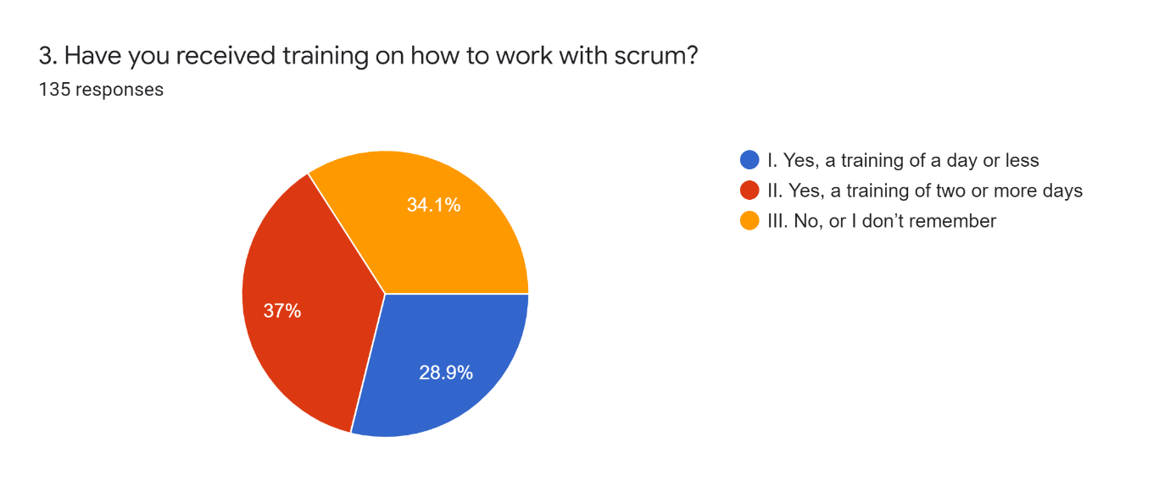

**Fig 3.2.1: Information about employees training**

We can see that 14.8% survey responder said that they have 11-16 members on their team and 5.9% said that they have more than 16 members in their team. The more the team members increase the more the communication problem arises.

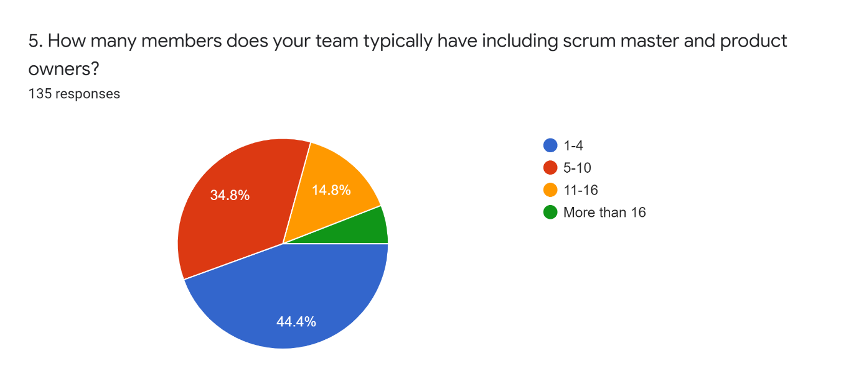

**Fig 3.2.2:** **Information about the size of a team**

48.9% responder said that teammates are working in a different room. This may arise communication problems as well.

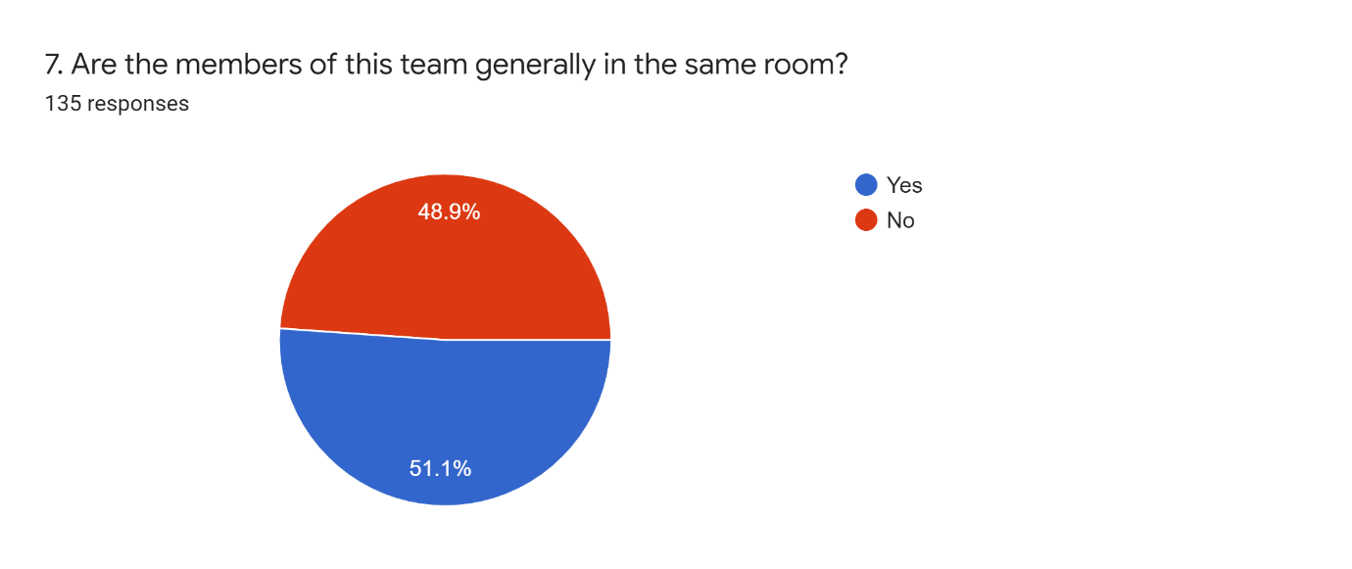

**Fig 3.2.3: Information about sitting position**

28.1% responder said their team doesn't focus on quality improvements. This may arise quality issues.

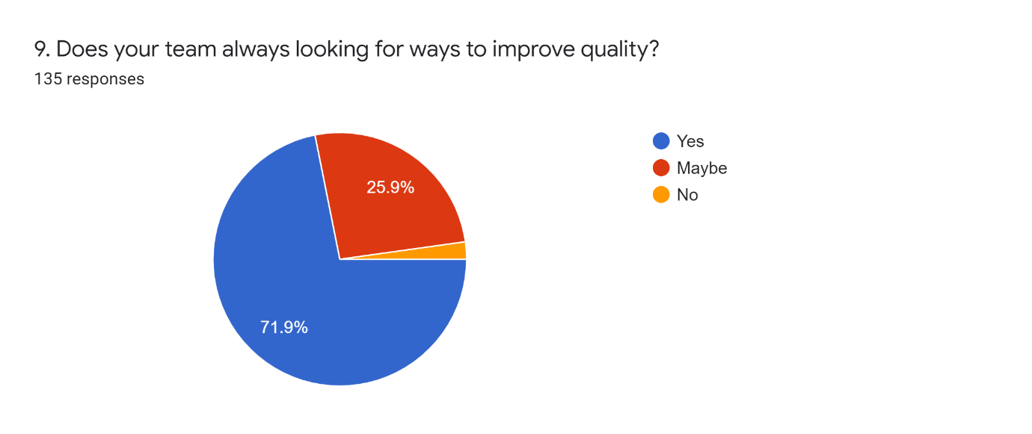

**Fig 3.2.4: Information about quality assurance**

29.6% of respondents said they don’t have the best control over scheduling. This may arise inadequate time allocation.

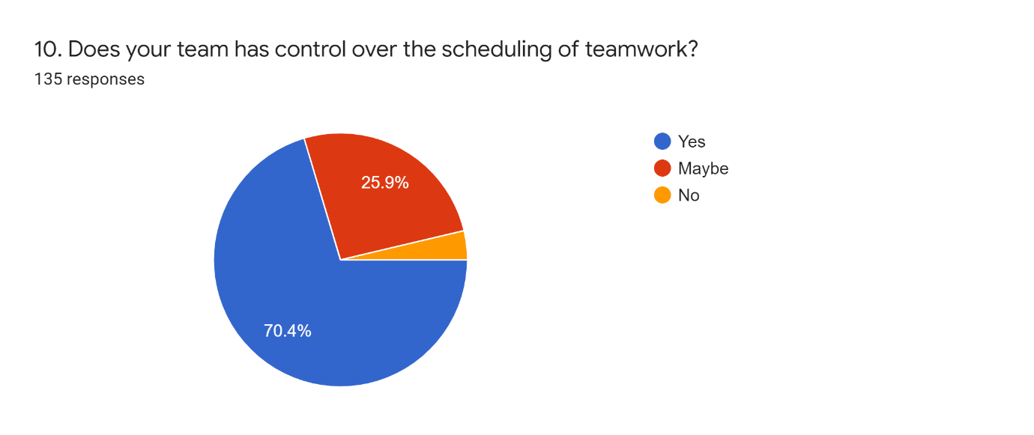

**Fig 3.2.5: Information about schedule controlling**

There are some minor problems as well which are negligible for now.

**3.3 Proposed solution**

Proposed solution describes how the companies can keep using Scrum and improve their output regarding the improved quality and better time management. For this we encourage every company to arrange a training session of at least 2-7 days on scrum about how it works and how to get the best output. We would also like to suggest they place a whole group in a single room if possible. If not possible then make a proper management for communication and after each sprint arrange a short meeting.

The companies should focus on the quality improvements as well.

Most importantly they should focus on proper documentation. For this they should focus on proper documentation. For this they should focus on product vision, case study of the product, product increment and sprint goals. At last, at the time of releasing the product a proper documentation is necessary.

**3.4 Proposed Model:**

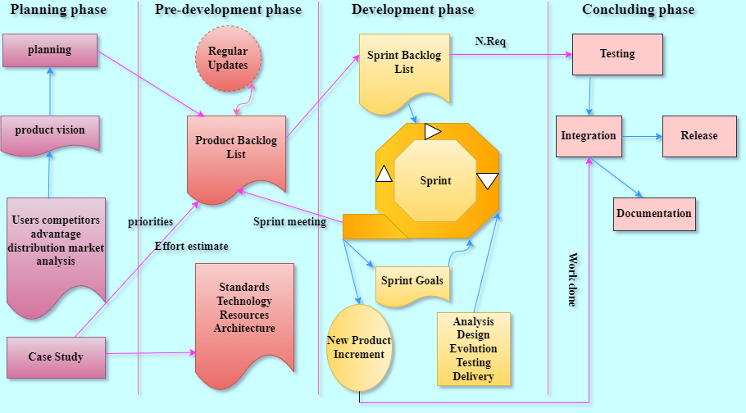

**Fig 3.4.1: Proposed model of scrum framework**

**3.5 Summary of proposed model**

We have tried to generate a model for the betterment and getting better output from SCRUM framework in this model we divided the whole process into four different phases. These are:

I. planning Phase

ii. Pre- development Phase

iii. Development Phase

IV. Concluding phase

As it is visible, we have extended total phases from three to four. We have focused more on a planning as we think planning is vital in the SCRUM and we made that thinking from the survey output. Now let’s, tear the phases

**i Planning Phase**

This is the very beginning to the phases. Here all the vital planning happens for the future work. Here product vision is also considered by the team members. The better I they snake the vision the better the planning goes there are some other factors like competitor, advantage distribution, market analysis are considered in this phase. Case study also takes place in this phase. For detailed study about any product or outcome of the product, case study is needed.

**ii. Pre-Development phase:**

Product backlog list is the main part here. All the plantings, case studies goes into product backlog list. To be exact this is a list of new features, changes to existing features that a team deliver in order to achieve a specific outcome. The product backlog list updates regularly until the work is done standards, Technology, resources, architecture are also considered in this phase. Sprint meetings are also a part of this phase.

**iii. Development Phase**

This is the third phase of the process. In this phase Sprint is the most important aspects. Here, the development team will work to accomplish specific goals or a task. Sprints can be called as iterations as well. A sprint goal visualizes the desired outcome of a sprint. A sprint gets all its requirements from Sprint backlog list, in this list items that are to be added in a particle sprint are stored. The sprint backlog list updates regularly. Analysis, design, evolution testing delivery are considered here after one iteration is completed, we get product increment. It is the result of ongoing improvement and development,

**iv: Concluding Phase:**

This is the final phase of the process, when there remain no requirements testing process starts. After a Successful testing scenario, integration starts there can't be new product increment in this level. After that the final product releases and documentation is done.

**CHAPTER 4: RESULTS AND ANALYSIS**

**4.1 Survey Results**

Our survey was focused on SCRUM about how it works, what are the advantages, what are the drawbacks as well as how it performs in the current market. After getting the responses we have proposed some solutions as well as a new model to overcome the drawbacks. In this part we will elaborate the survey results.

We got 135 responses from various of employees.

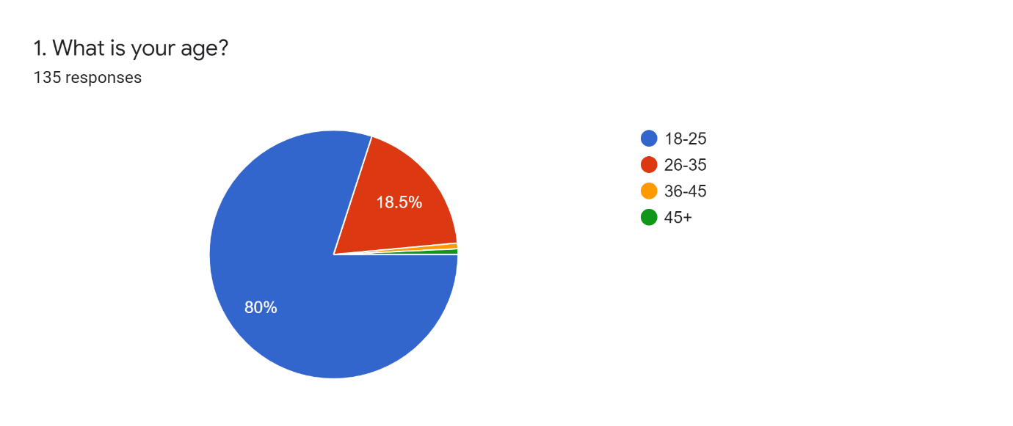

**Fig 4.1.1: Information about age**

Our first question was, “What is your age?”. As for the response we got 80% of people with 18-25 years of age, 18.5% of people with 26-35 years of age, rest are 36-45 years and 45+ years of age.

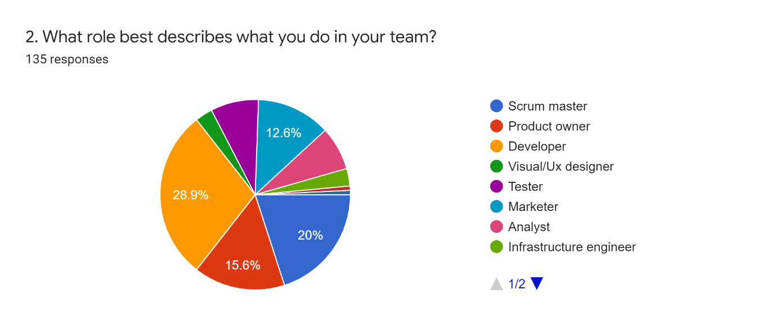

**Fig 4.1.2: Information about employees role**

Our second question was, “What role best describes what you do in your team?”. As for the response we got 20% of people with scrum master, 15.6% of people with product owner, 28.9% people with developer, 12.6% people with marketer, rest are visual designer, tester, analyst, infrastructure engineer.



**Information about employees training**

Our third question was, “Have you received training on how to work with scrum?”. As for the response we got 37% of people with training of two or more days, 34.1%% of people with No or I don’t remember, 28.9% people with training of a day or less.

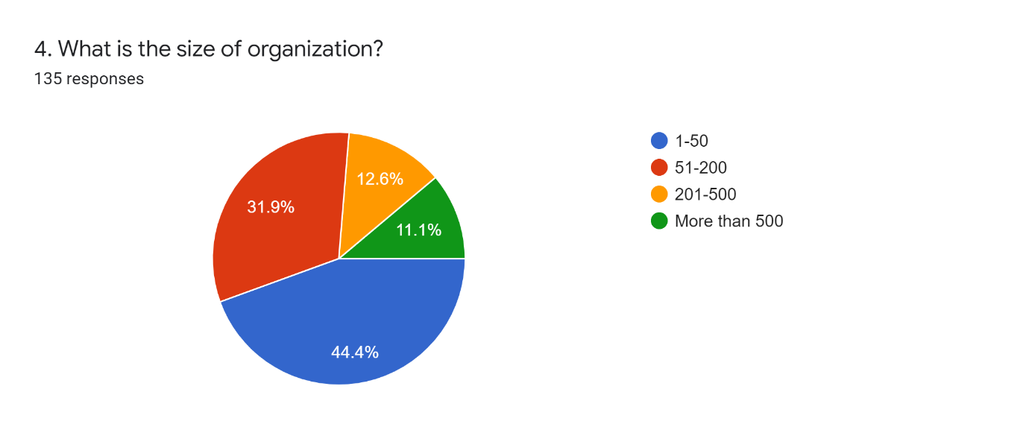

**Fig 4.1.3: Information about organization size**

Our fourth question was, “What is the size of organization?”. As for the response 31.9% said they had 51-200 employees in their company, 44.4% said they had 1-50 employees in their company, 12.6% said they had 201-500 employees in their company and 11.1% said they had more than 500 employees in their company.



**Information about the size of a team**

Our fifth question was, “How many members does your team typically have including scrum master and product owners?” As for the response 44.4% said they had 1-4 members in their team, 34.8% said they had 5-10 members in their team, 14.8% said they had 11-16 members in their team. Rest is more than 16.

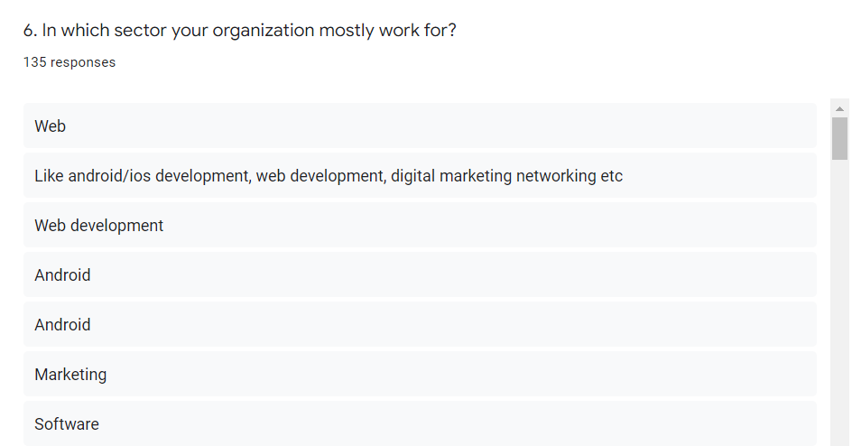

**Fig 4.1.4: Information about organizations work**

Our sixth question was, “In which sector your organization mostly work for?” As for the response we got various answers.



**Information about sitting position**

Our seventh question was, “Are the members of this team generally in the same room? we received feedback from 135 people. Of these, 51.1% got the answer Yes. And received 48.9% of the answers are No.

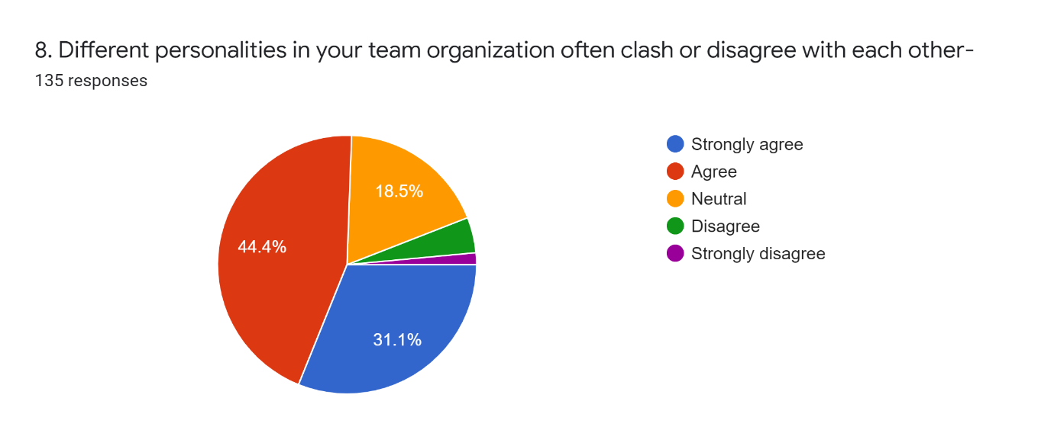

**Fig 4.1.5: Information about office environment**

Our eight question was, “Different personalities in your team organization often clash or disagree with each other”-As for the response we got 44.4% of people with Agree, 18.5% of people with Neutral, 31.1% people with Strongly Agree, rest are Disagree and Strongly disagree.



**Information about quality assurance**

Our ninth question was, “Does your team always looking for ways to improve quality?” we received feedback from 135 people. Of these, 71.9% got the answer Yes, received 25.9% of the answers are Maybe and rest are No.



**Information about schedule controlling**

Our tenth question was, “Does your team has control over the scheduling of teamwork?” we received feedback from 135 people. Of these, 70.4% got the answer Yes, received 25.9% of the answers are Maybe and rest are No.

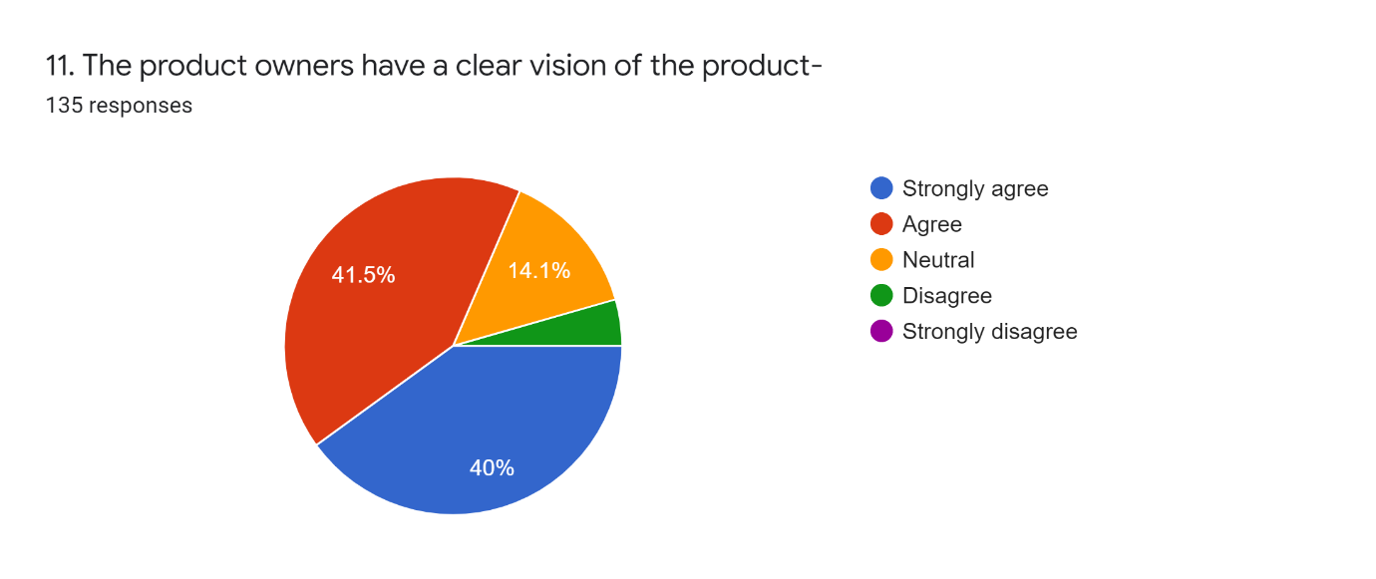

**Fig 4.1.6: Information about product owners knowledge**

Our eleventh question was” The product owners have a clear vision of the product-”-As for the response we got 41.5% of people with Agree, 14.1% of people with Neutral, 40% people with Strongly Agree, rest are Disagree and Strongly disagree.

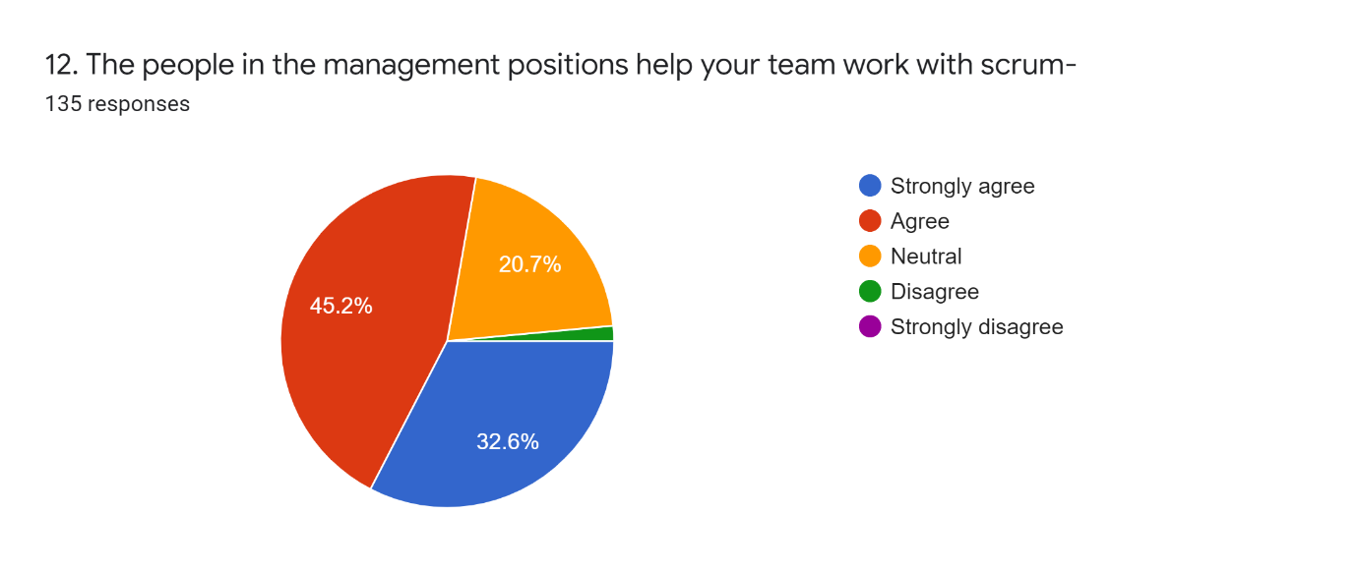

**Fig 4.1.7: Information about management cooperation’s**

Our twelfth question was “The people in the management positions help your team work with scrum-As for the response we got 45.2% of people with Agree, 20.7% of people with Neutral, 32.6% people with Strongly Agree, rest are Disagree and Strongly disagree.

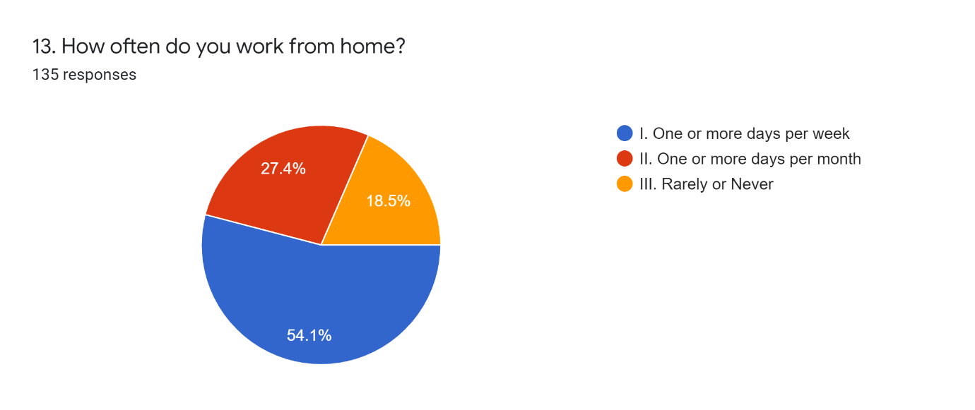

**Fig 4.1.8: Information about home office**

Our thirteenth question was, “How often do you work from home?” As for the response we got 54.1% of people work one or more days per week, 27.4%% of people work one or more days per month, 18.5% people work never.

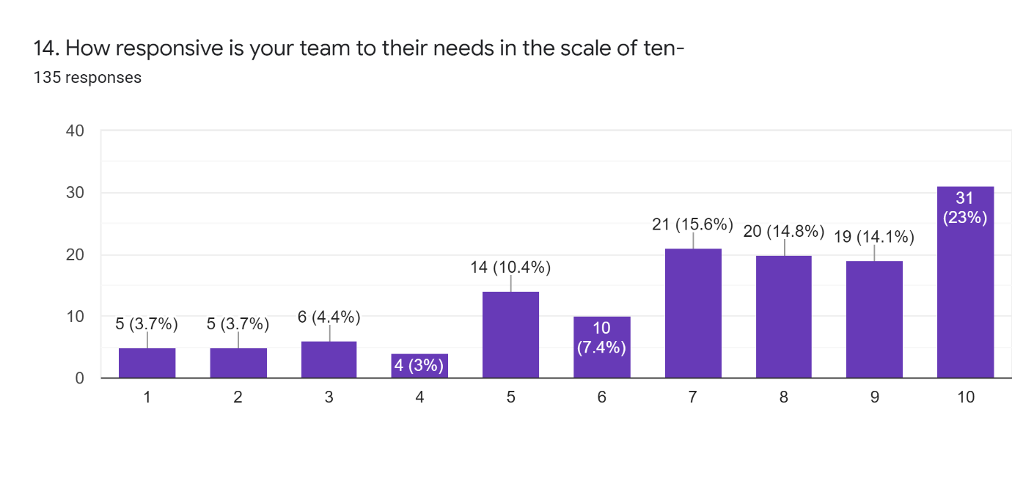

**Fig 4.1.9: Information about team responsiveness**

Our fourteenth question was” How responsive is your team to their needs in the scale of ten”. As for the response, we got variety of feedback in the scale of ten. Most of the feedback was between 7 to 10.

**4.2 RESULT ANALYSIS**

According to our survey results we can state that a huge number of companies use SCRUM for this office work. As SCRUM is one of the most famous frameworks of Agile, we can say that the productivity of SCRUM is very high. Despite some disadvantages SCRUM works pretty well in new or start-up companies as well as old or experienced companies. Companies may increase their productivity by overcoming the disadvantages. For this our survey will help them. As we have asked some important questions about the disadvantages and got the responses. New companies can be benefitted by our research and the old companies may modify to improve SCRUM and get benefitted as well.

**4.3 Advantages of Proposed Model**

To improve the current SCRUM framework, we proposed some solutions as well as a new model. As for the solution we think by following the proposed solution the companies will get benefitted as well as the productivity may also increase. As for the proposed model, we have offered a new model with four phases in it. We focused more on planning sessions by the thought of, " The better the planning is, the better the output will be." According to our survey results, we this by collaboration of the employees with our research the output will be better.

**CHAPTER 5: FUTURE WORK**

**5. Future Work:**

In this paper we have done a survey on some employees of different companies. We got various responses from them. We tried to improve as much as we can. But our survey was limited with very limited amount of audience and limited number of questionaries. Companies can still get help from our work but for more success we are preparing for a better and bigger survey to reach bigger audience to get bigger feedback. For this we will try to reach more companies for more audience. So basically, our future work might help to improve scrum as well as get more productivity from it.

**CHAPTER 6: CONCLUSION**

**6. Conclusion:**

For our thesis we studied about Scrum. Before starting we studied different research papers and books as well as we got information from internet including our topic and understood the necessity of proper project method in a company. Our research was mainly for those companies which were using Scrum for their company but not doing well with their company. We studied that a proper project method can pull up a company from a hole and for that our research was to improve scrum as much as we can. There were many papers and research book about Scrum, but there was not enough good research in improving the problems for our country companies. However, our survey and result were limited because we had limited questionaries with limited audience. The survey as well the proposed solution along with the whole research may help the companies to improve and overcome any situation. However, we are also looking for better results as our future work.

**References:**

[1] C. Wallace, S. Mohan, D. Troy, and M. E. Hoffman, “Scrum across the cs/se curricula: A retro-spective,” inProceedings of the 43rd ACM technical symposium on Computer Science Education.ACM, 2012, pp. 5–6.

[2] J. Sutherland and J. Sutherland,Scrum: the art of doing twice the work in half the time. Currency,2014.

[3]P. Sincharoenpanich, N. Chantachaimongkol, ―Critical factors for implementing the Scrum software development methodology,‖2013.

[4]P. Kettunen, ―Adopting key lessons from agile manufacturing to agile software product development—A comparative study.,‖Technovation, , pp. 29(6), 408-422, 2009.

[5]P. Rola, D. Kuchta and D. Kopczyk, ―Conceptual model of working space for Agile (Scrum) project team.,‖Journal of Systems and Software, , pp. 118, 49-63, 2016.

[6]S. C. Misra, V. Kumar and U. Kumar, ―Identifying some important success factorsin adopting agile software development practices.,‖journal of systems and software, pp. 82(11), 1869-1890, 2009.

[7] J.Han and Y. Ma, ―Software Project Planning Using Agile. In Progess in Systems Engineering,‖ Springer International Publishing., pp. 333-338, 2015.

[8] J. A.Gliem and R. R. Gliem, ― Calculating, interpreting, and reporting Cronbach’s alpha reliability coefficient for Likert-type scales.,‖ Midwest Research-to-Practice Conference in Adult, Continuing, and Community Education., 2003.

[9] T. Dyba and T. Dingsoyr, ― Empirical studies of agile software development: A systematic review.,‖ Information and software technology, pp. 50(9), 833-859., 2008.

[10] K. Conboy, B. Fitzgerald, ―Toward a conceptual framework of agile methods: a study of agility in different disciplines.,‖ ACM, pp. 37-44, 2004.

[11] T. Chow and D. B. Cao, ―A survey study of critical success factors in agile software projects,‖ Journal of systems and software, pp. 81(6), 961-971, 2008.

[12] J. J. Cho, ―An exploratory study on issues and challenges of agile software development with scrum,‖ p. 599, 2010.